UAV anti-aircraft equipment
Product introduction and instructions

Thank you for using this TX-JZ02 UAV anti-system fixed station.

In order to enable you to operate the equipment skillfully as soon as possible, we have provided a user manual with detailed contents, from which you can obtain knowledge about product introduction, use methods, system settings, safety precautions and other aspects.

The UAV jammer has passed the strict certification of the Safety and Police Electronic Equipment Quality Testing Center, the Electronic Product Quality Testing Center, and the Electromagnetic Leakage Emission Protection Product Testing Center of the Ministry of Public Security.

We are very careful and rigorous in the preparation of this manual, and believe that the information provided in the manual is correct and reliable. However, there will inevitably be errors and omissions. Please be more tolerant and warmly welcome your correction.
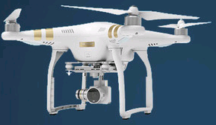
This product is suitable for prohibiting drones from flying to places!

1、 R&D background
1. Confidential units such as military industrial forces divulge secrets:

Small multi-rotor UAVs are widely used due to their low price and easy operation. In the hands of "people with ulterior motives", UAVs can become a weapon for stealing secrets and pose a serious threat to the military, military and other important national defense facilities. For example, the training of a certain part of the rocket army was filmed by unmanned aerial vehicles. As shown in Figure 1.1: 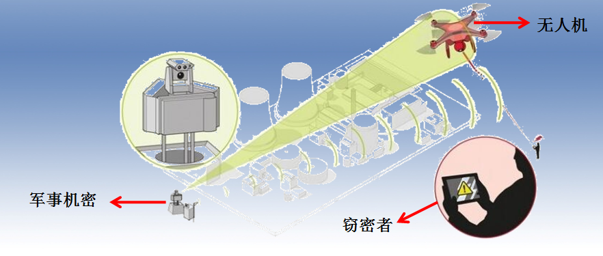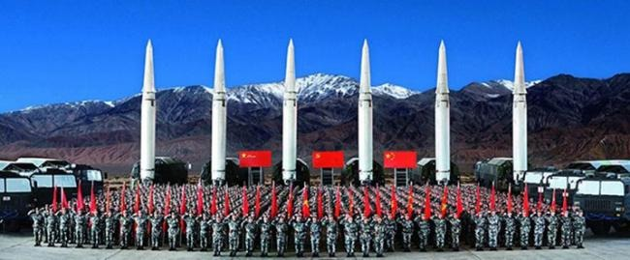 Figure 1.1: Disclosure of secrets by military and industrial forces and other confidential units
2. Interference with flight:
The theoretical elevation and visual operation of UAVs are generally less than 1000 meters, while the flight route of general police helicopters is sometimes only 400 meters high. For some urban management needs, low altitude flight is even below this altitude. In this way, there is a conflict point between the two in the air. Once an accident occurs, the consequences are unimaginable. For example, the airport has been interfered by UAVs for many times, resulting in flight delays, forced landing of aircraft at the standby airport and other accidents.
2、 Product Introduction
The fixed quality control instrument equipment has a more compact structure and is fixed and installed unattended. At the same time, the proportion of antenna position is increased, and the anti-aircraft capability of UAV is enhanced. On the operation button, the original three frequency buttons 2.4G and 5.8G are simplified to the current two function buttons for return,. Press and hold the return button to start 2.4g and 5.8g at the same time, greatly simplifying the use process.
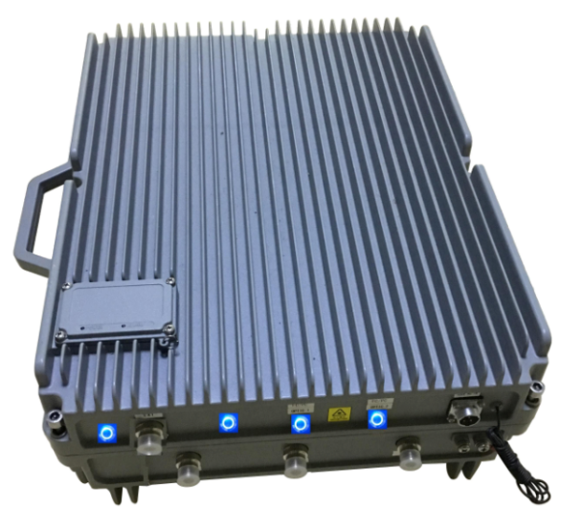
Now, let's introduce this UAV jamming system to you and let you know the position, parts and other hardware functions of all buttons.
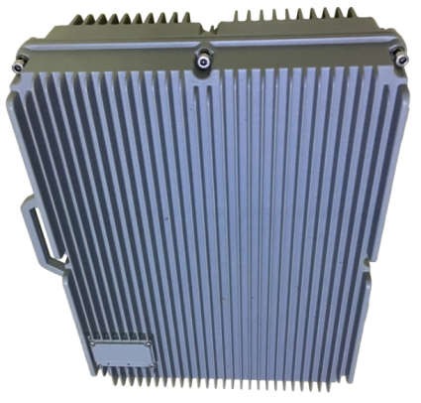
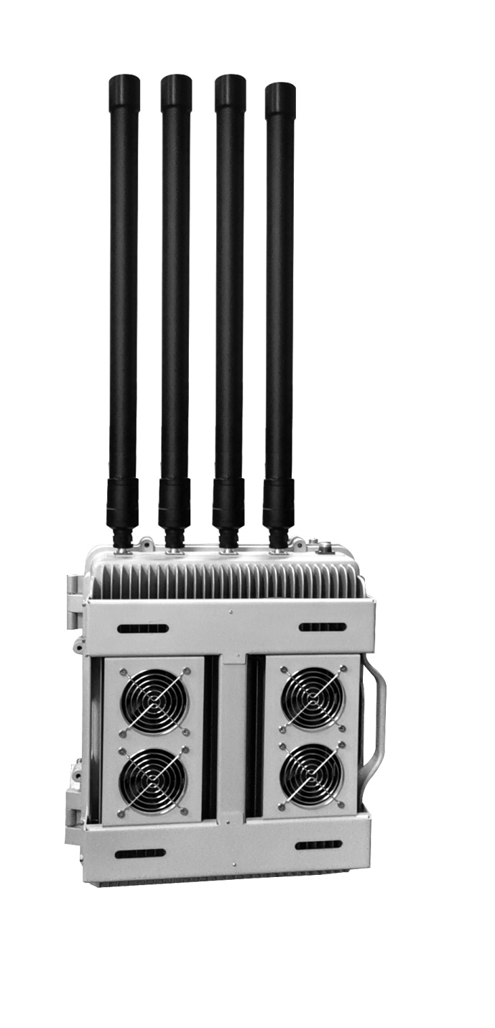 The equipment works continuously for 24 hours
技术指标

输出端 | 工作频率 | 平均输出功率 | 信道输出功率
2.4G | 2400-2485MHz | 47 dBm±1 | 30dBm/30KHz(min)
2.4G | 2400-2485MHz | 47 dBm±1 | 30dBm/30KHz(min)
5.8G | 5720-5850MHz | 45 dBm±1 | 25dBm/30KHz(min)
5.8G | 5720-5850MHz | 45 dBm±1 | 25dBm/30KHz(min)
电源:AC220V-DC24V 干扰半径:1500m@可视网络信号状况
电能消耗:157W 重量:25Kg 尺寸（宽×高×深）:500×450×250毫米
技术特点

1、工作原理：
“质控仪”采用超高频宽带干扰技术和射频抑制技术，切断无人机与遥控器之间的联系，从而迫使无人机进行强制着落或者强制返航。
且无人机在受到管制后，切断了图传通道，将不能传输视频、航拍照片以及收不到地面遥控者对其发出的任何指令，从而达到对关键区域的防护, 防止隐私被泄露的目的。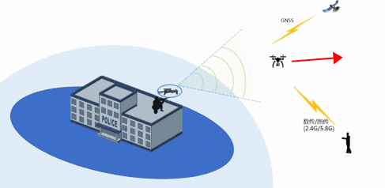

模式 | 频率 | 频段 | 状态
返航 | 2.4G | 2400-2500MHz | 打开
 | 5.8G | 5700-5900MHz | 打开

◎ 采用超高频宽带无缝干扰技术

◎ 单路开关技术控制输出。

◎ 有效功率（信道功率）高，干扰距离大。

◎ 有效分段，只干扰无人机控制和视频传输频率，不会对其他的频率造成干扰。

◎ 进口器件。缓启动电路设计可避免机械开关产生的打火现象，集成度高工作稳定。
连接性能

- 用于连接定向板状天线的4个N型接口(2.4G/5.8G)对应设备低部4个的N型使用，接头拧紧用防水胶布缠好。

- 一个电源市电航空接口 (AC220 IN)

系统配件
您所购买的无人机干扰仪系统是由配件所组成。这些配件包括主机、定向板状天线、外箱、交流电源线。本节将简短地说明主要配件功能。
主机开关功能说明

◎ 设备通电后风扇工作
◎ 5.8G开关开启，电源灯亮；用途无人机飞入管辖内后，对无人机遥控或视频传输干扰，使无人机遥控或视频传输失去信号。
◎ 2.4G开关开启，电源灯亮；用途无人机飞入管辖内后，对无人机遥控或视频传输干扰，使无人机遥控或视频传输失去信号。
◎ 所有开关打开时，用途无人机飞入管辖内后，使无人机机在低空中停悬6秒左右，原地低空垂直降了，达到无人机击落，此时无人机飞手遥控无法控制。

天 线介绍
◎ 2.4G/5.8G
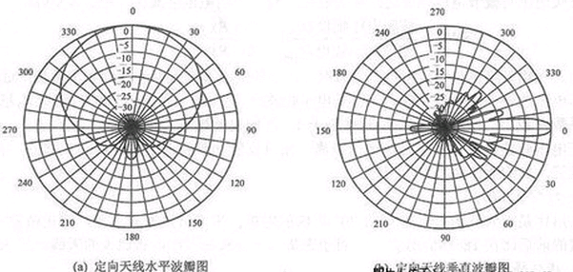

打开组件包装箱
小心地把包装箱打开。将所拆开的包装箱保留好，以备将来搬动或载运之用。
检查所打开的项目是否完好。如果发现现有任何缺件或损坏，请速与您的经销商联系。

系统配件

在连接完所有组件后，将连接天线，对应端口拧紧。
在您连接完所有周边及连线后，请依下列步骤开启您的设备：
固定设备与天线

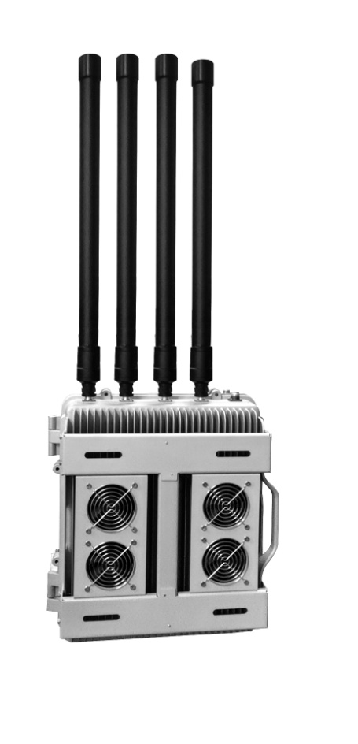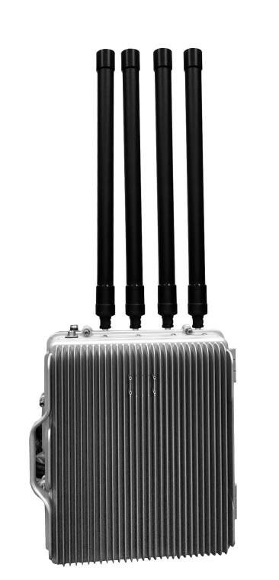

开启您的设备

◎ 首先将设备与天线各线缆连接无误。
◎ 板状天线固定安装高度对准管辖区域发射。
◎ 设备电源线连接市电AC220V。
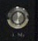
◎ 开启每路 开关，功率输出。

关闭您的设备

◎ 关闭所有开关，不进行干扰

干扰性能

专门针对可视的无人机干扰，有效距离为飞手离无人机在100米左右范围，干扰1500米以上。

干扰位置

使用天线对应干扰区域模拟，如下图：

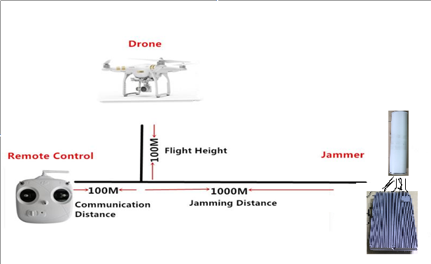

无人机基站信号干扰设备清单

序号 | 产品名称 | 单位 | 数量 | 频段 | 发射功率 | 备注
1 | 防水防爆电源机箱 | 台 | 1
2 | 发射天线 | 个 | 4 | 2400-2500M  5700-5900M
3 | 2.4G功放模块 | 块 | 2 | 2400-2500M | 100W
4 | 5.8G功放模块 | 块 | 2 | 5720-5860M | 60W
5 | AC220V/DC24V电源 | 个 | 2
6 | 防水散热高速风扇 | 个 | 4
7 | 华为防雷器 | 个 | 1

注意事项
◎本设备按防水设计，均可室内、室外可以安装使用，使用前必须保证各输出端口与天线对应连接无误后通电开启各开关。（端口长期空载会导致设备损坏）
◎ 必须先将天线连接好，再接通电源。主机工作时禁止取下天线。
◎ 干扰仪应放置在通风较好的地点，尽量避开大型物体遮挡，以保证屏蔽效果。
◎ 在室外使用安装时，接头连接线、接头要做好防水、避免暴晒。
- 天线应垂直方向对着管辖区域使用。

问题解答

◎ 无人机干扰仪会不会干扰其它电子设备正常工作？
不会的。这是因为，无人机干扰仪发出的电磁信号完全落在国家规定的工作频带内，只会对通信产生屏蔽作用。
◎ 干扰仪对人体和手机是否有害？
请使用者放心,发射的电磁信号强度是很弱的，测试资料表明，这种信号强度远远不会对人体构成危害。同时，只是干扰的前向信号，使无人机不能与操作遥控建立联系，因此，根本不会对无人机本身产生任何损坏。
◎ 无人机干扰仪在室内和室外使用时距离有差别吗？
有。一般情况讲，室外信号使用室外，所以室内干扰效果差。严格说：不论是在室内，还是在室外使用，；无人机干扰仪的有效作用距离与当时的电磁环境及周边环境有一定关系。如距的远近、安放的位置等。
◎ 无人机干扰仪工作一段时间后机壳发热,长时间工作会不会损坏机器？
感谢您的细心,这是一种正常现象。在设计上,我们正是利用全铝机壳的导热性来辅助散热的。从而能够保证机器长时间稳定工作。因此，机壳发热不会损坏机器。

服务无止境……

本手册汇集了本公司的无人机干扰仪各型产品，
因时间仓促，难免有疏漏之处。如有不明之
处，敬请见谅并指正，同时我们将随时为您
解答并竭诚为您服务。
我们衷心希望本手册能给您带来方便，
鉴于本手册中所涉及的标准、技术要求及产
品各种规格，随着技术进步和时间推移都有可能发生变化，因此，我们保留修改权，如有更改恕不另行通知。

