1.5KMUAV-JAMMER

1. background
Unmanned aircraft, or "UAV", are unmanned aircraft operated by radio remote control equipment and self-provided program control devices, or operated completely or intermittently by on-board computers. UAV can be divided into military and civilian use according to its application field. In the military side, drones are divided into reconnaissance aircraft and target aircraft. Civil aspect, UAV + industry application, is the real need of UAV; at present, in aerial photography, agriculture, plant protection, micro selfie, express transportation, disaster rescue, wildlife observation, monitoring infectious diseases, mapping, news reports, power inspection, disaster relief, film and television shooting, romance and other applications, greatly expand the use of UAV itself, developed countries are also actively expanding the industry application and development of UAV technology.
But in China, the drone "black flying" incidents also occur frequently. A large number of drone "black flying" incidents have serious safety risks. Its direct harm is to seriously disrupt air traffic control and endanger air traffic safety. The "Black Fly" incident may also endanger people's lives and property, and disturb public order. Disorderly flight of UAV is easy to interfere with the normal operation of military and civilian aircraft, and may even lead to flight accidents. Because the UAV pilot knows nothing about the flying airspace, it can easily affect the flight activities of other military and civilian aircraft, interfere with the normal aviation order, and seriously lead to accidents, causing losses of life and property to the country and people.

2. Technology implementation
This product disturbs the GPS, flight control, and map transmission signals of the suppressed UAV to lose control, and achieve the purpose of protecting the key targets and areas. The technical scheme is: a uav interference method, the scheme is as follows: blocking interference mode to block the communication between the UAV GPS receiver and the remote control; L-band transmitter interferes with the UAV GPS signal; S-band transmitter interferes with the UAV flight control and map transmission signal; C-band transmitter interferes with the UAV flight control and map transmission signal. Further, the blocking interference mode is used to block the GPS receiver of the UAV and the communication between the UAV and the remote control to make it impossible to locate and lose control. Transmitter interference frequency and power are as follows: frequency band interference frequency transmission power note L band 1575 ± 5 MHz / S band 2450 ± 50 MHz / C band 5790 ± 70 MHz
The company independently develops and produces the UAV jammers, which can block all satellite positioning signals, including: GPS / Beidou / Glonas / Galileo; and block the 2.4G and 5.8G frequency bands, forcing the remote control, map transmission and signal interruption to achieve the function of crash landing / return / hover, with the interference distance and the open ground greater than 800-3000 m.

3. Product function advantage
- Independent research and development, and production.
- Cut off all the signal contact between the drone and the controller. The drone remote control has failed.
- The drone cannot locate it, forcing it to land, hover or turn back technical parameter
frequency range | service frequency | port | Power output per lane
2.4G | 2400-2485MHz | 4 Road | 45 dBm±1
5.8G | 5720-5850MHz | 4 Road | 44 dBm±1
1.5G (optional) | 1565-1585MHz | 4 Road | 40 dBm±1
Total power: 170W; Power supply: AC220V Interference range: 800-3000m@ visual network signal condition

5. product picture

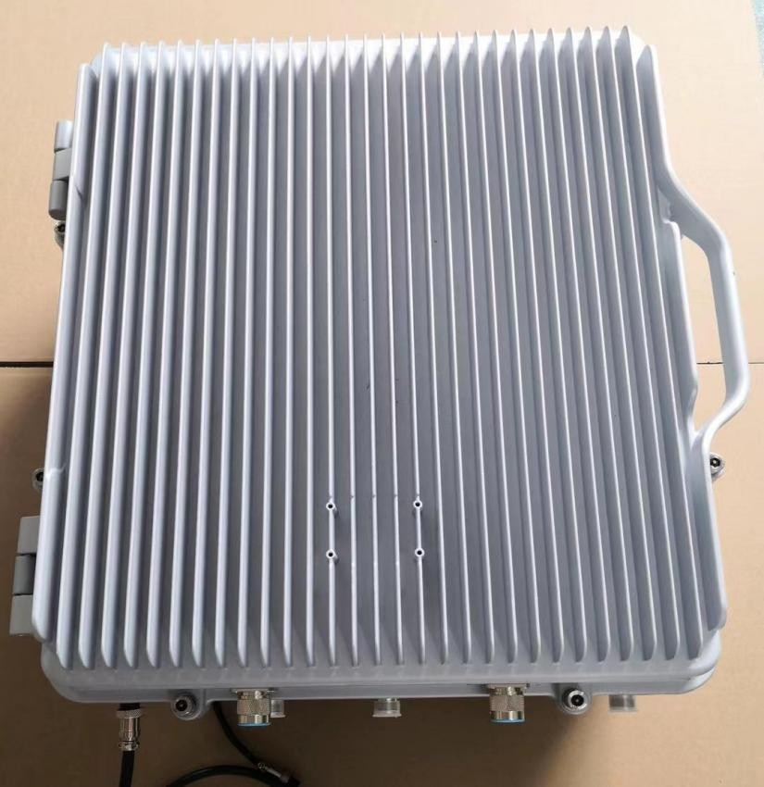

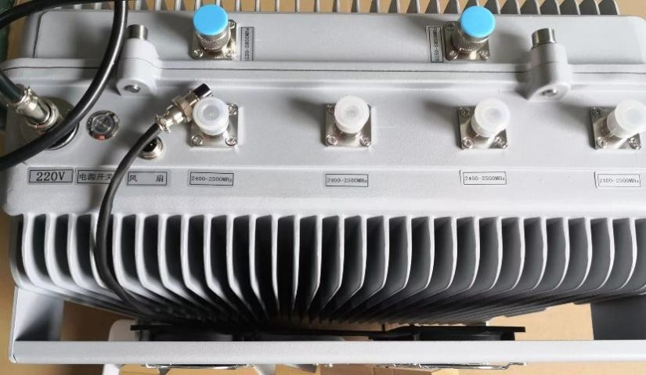

six, Device connection diagram

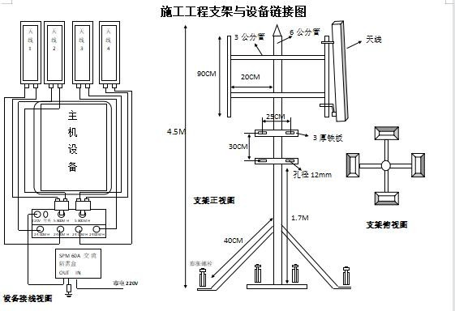
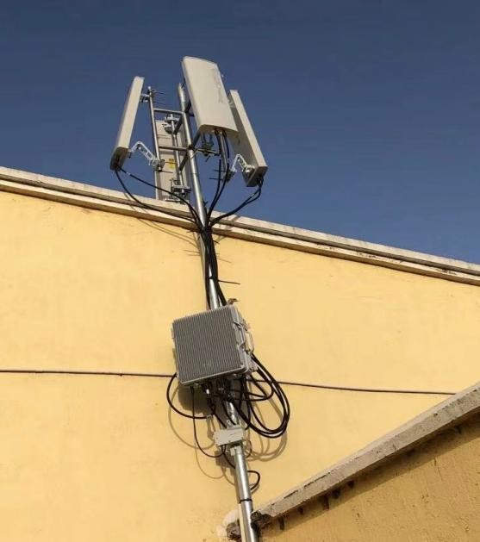
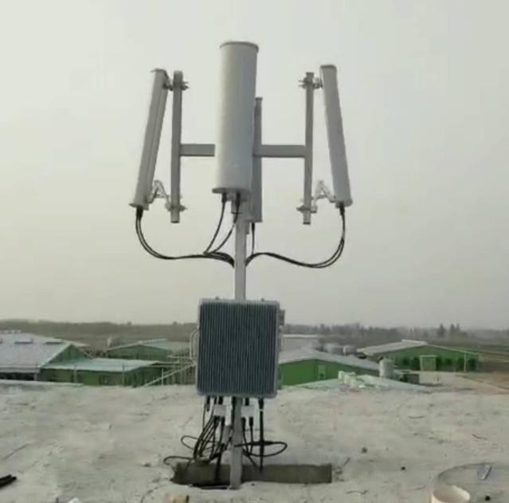
seven, Field installation with the antenna coverage angle
eight, Installation location selection
- The best location of the equipment covers the central location of the area
- There is no obstacle in the equipment antenna with direct view distance Turn on the device
- First, connect the equipment with the antenna cables.
- The plate antenna is aligned with the jurisdiction area.
- The equipment power cord is connected to the mains power AC220V.
- Connect device fan
- Open the power switch (see if the power indicator is on)

ten, Drone test

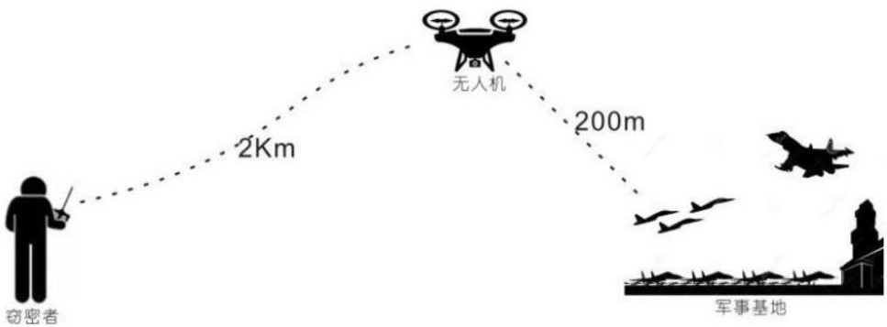

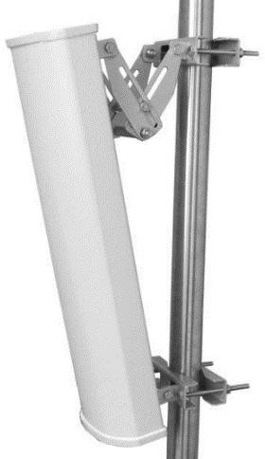
XI. Parts- -4 plate-shaped antennas

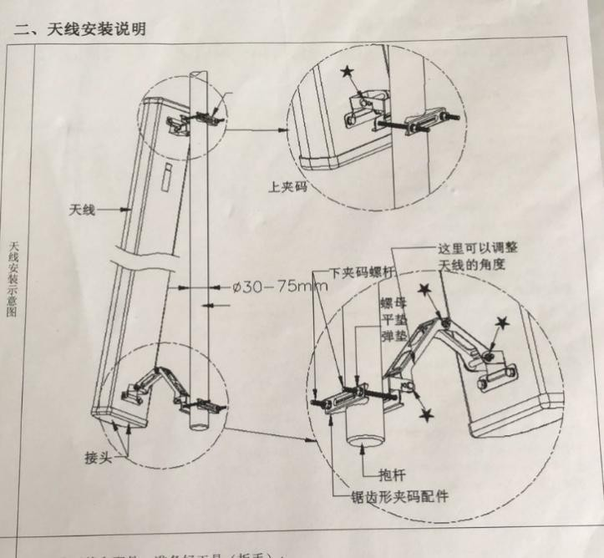
Twelve, accessories: lightning arrester, function separator, jumper.

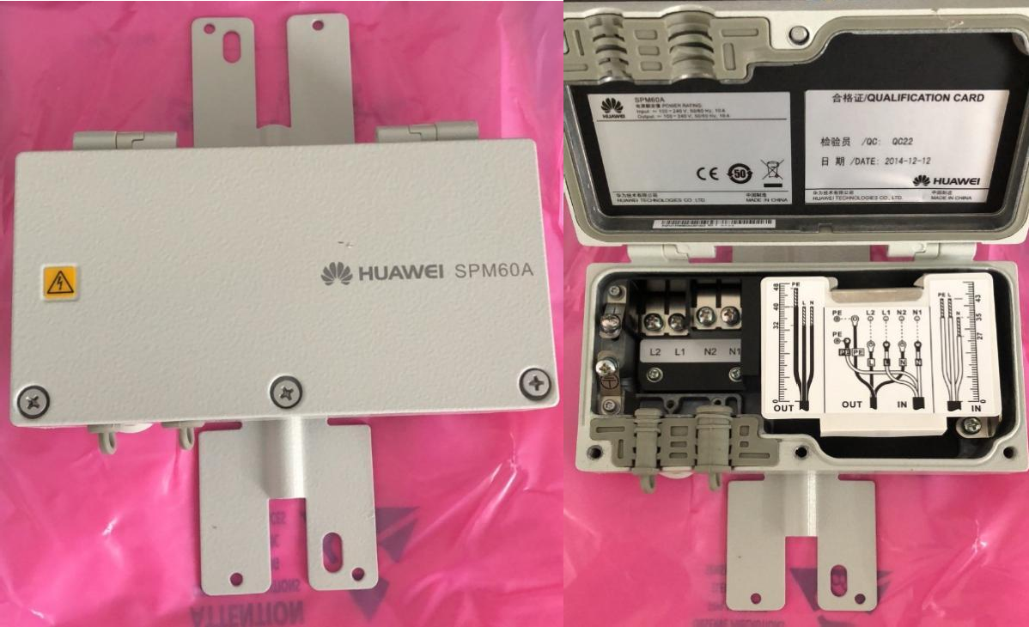
13. Answer the questions
- Will the drone jammer interfere with the normal operation of other electronic devices?

un. This is because the electromagnetic signals emitted by the drone jamming instrument fall completely in the working frequency band stipulated by the state, which only shields the communication.
- Is the jamming mer harmful to human body and mobile phone?

Please rest assured that the intensity of the electromagnetic signal is very weak, the test data show that this signal intensity is far from harm to the human body. At the same time, it is only the forward signal of interference, so that the drone can not be connected with the operation remote control, so there will not cause any damage to the drone itself.
- Is there a difference between drone jammers in indoor and outdoor use?
have. Generally speaking, the outdoor signal is used outdoors, so the indoor interference effect is poor. Strictly speaking: whether used indoors or outdoors; the effective function distance of UAV jammer is related to the electromagnetic environment and surrounding environment. Such as the distance, the location of the placement, etc.
- The shell is hot after working for a period of time. Will the machine be damaged after working for a long time?

Thank you for your care, this is a normal phenomenon. In the design, we use the thermal conductivity of the all-aluminum case to assist the heat dissipation. This can ensure that the machine works stably for a long time. Therefore, the housing heating will not damage the machine.

