Three-channel UAV anti-shield
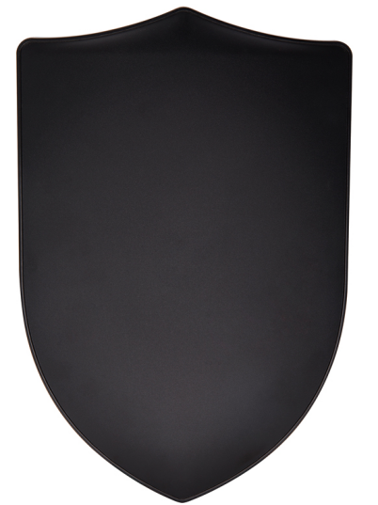
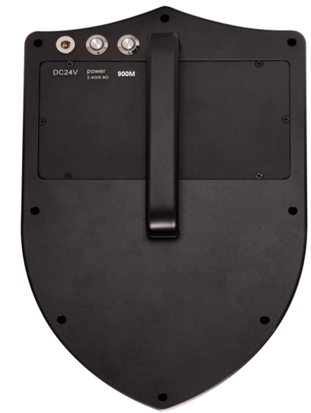
充电口Charging port

按钮开关
2400~2483MHz
5825~5852MHz

按钮开关
830~919MHz

01.Product description
TX-WRJ-01 is a directional shield type anti-aircraft equipment with lithium battery, which is easy to operate and can realize single-frequency control. The equipment uses narrowband interference technology and radio frequency suppression technology to cut off the connection between the UAV and the remote controller, thus forcing the UAV to return to the sea. After being controlled, the UAV will cut off the image transmission channel, and will not be able to transmit video, aerial photos and receive any instructions from the ground remote controller, so as to protect the key areas and prevent the privacy from being leaked.
02.Main index parameters
Operating frequency band/power | 830-919MHz Power 10W
 | 2400-2483MHz Power 30W
 | 5825-5852MHz Power 30W
Battery capacity | 24V 6.5A/H
Countervailing capability | course reversal
Reverse distance | 500~1000m
Counter-angle | 30°
Duration | 1小时
Charging mode | 29.4V charging adapter
size | 280*180*70mm
weight | 3.2kg
03.重点行业
机场、公检院系统、监狱、看守所、戒毒所、保密机构、部队、⼤型赛
事、演唱会、重要会议、政府机关、反恐领域等重要地点、设施，需要空
间保密、无人机机管控的地域。

