1.5km UAV Jammer LCD Display 5 Band 5.8G 2.4G 1.5G Drone Signal Jammer
Model.GW-UAV102P；
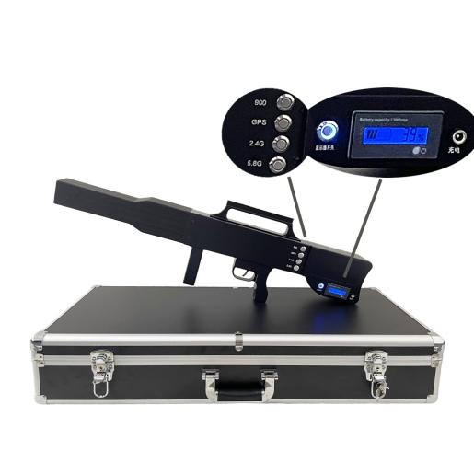

With drone sales expected grow exponentially in the near future, and an increasing number and severity of drone incidents occurring daily, We launched Drone Gun to respond to nefarious use of consumer and commercial drones and the resulting need for effective countermeasures to drone intrusions. GREETWIN aims to help public and private sector customers, where allowed by law, take proactive measures against airborne threats to safety, security, and privacy.

Portable light UAV Drone Jammer, Built-in high gain directional antenna, Built-in 5 sets of independently operated RF working unit, can choose to on/off GPS to drive the drone or force the drone to land, can be transmitted shielding interference signals to the surrounding 45-degree angle, Coverage (1000-1500m) can be comprehensive and stable uninterrupted shielding of the GPSL1, WIFI 2.4G, and 5.8G bands in the UAV frequency band.

Product Description
Feature
1.High-gain 8dbi built-in antenna, Jamming range up to 1.5KM.
2.Working for more than 60 minutes with fully charged.
3. the customer can switch according to their requirements.
4. There is a power switch in the visible part of the body, including a power indicator, which can be operated directly by one hand. 5.Independent design of control switch, aiming at stopping peeping, driving away, and forcing to land.

Parameter:
Channel |  | Working Frequency | Output power(±1dBm)
CH1 | 2.4G | 2400-2485MHz | 44.7 dBm (30W)
CH2 | 5.8G | 5725-5850MHz | 44 dBm(25W)
CH3 | GPSL1, Glonass, BDS | 1575.4±2.5MHZ(1.5G-GPS)  1602±5MHZ(1.5G-GLONASS)  1561±2.5MHZ(BDS) | 44.7 dBm (30W)
CH4 | Remote | 860-930MHz | 44.7 dBm (30W)
Power supply mode |  | Inside battery 1h: 28V, 7.5A;  Or External battery
Turn on/off |  | 5 Independent Switch for each band
Total Outpower |  | 145W
Battery working time |  | 45 minutes
Working temperature |  | -20ºC to +55ºC
Power consumption |  | 140W
Weight |  | 4.3KG, Packing Weight:7KG
Size |  | 660X290X50mm
Directional Panel Antenna |  | 8dBi

